Round Robin Algorithm
Steps to find waiting times of all processes:
P1=8ms, TQ=5ms
Time Quantum can be entered by the user
1- Create an array rem_bt[] to keep track of remaining burst time of processes. This array is initially a copy of bt[] (burst times array)
2- Create another array wt[] to store waiting times of processes. Initialize this array as 0.
3- Initialize time : t = 0
4- Keep traversing all the processes while all processes are not done.
Do following for i'th process if it is not done yet.
a- If rem_bt[i] > quantum
(i) t = t + quantum
(ii) rem_bt[i] -= quantum;
c- Else // Last cycle for this process
(i) t = t + rem_bt[i];
(ii) wt[i] = t - bt[i]-arrivaltime[i]
(ii) rem_bt[i] = 0; // This process is over
Once we have waiting times, we can compute turn around time tat[i] of a process as sum of waiting and burst times, i.e., wt[i] + bt[i]
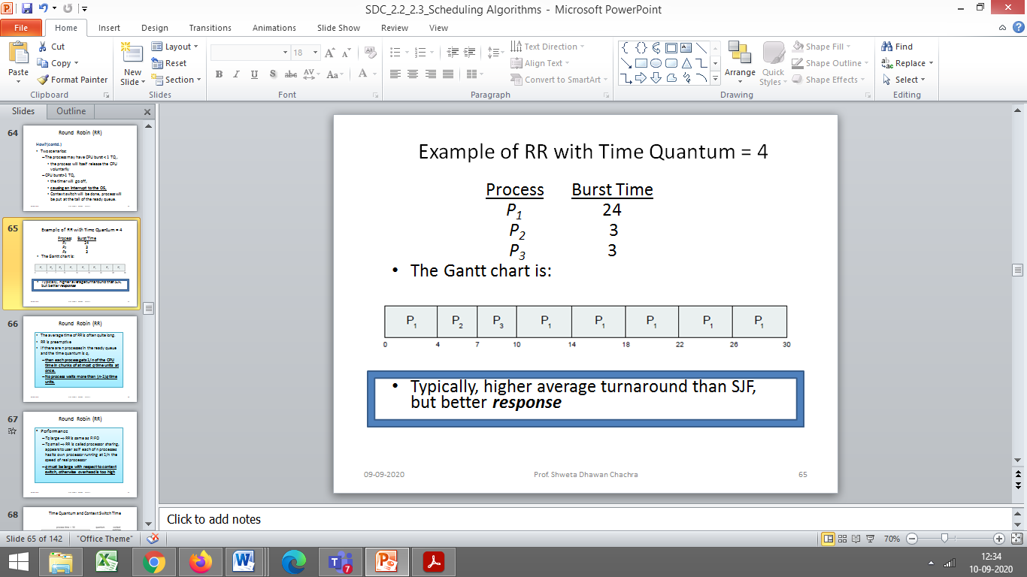

Preemptive SJF
Implementation:
Take a counter “complete” to keep a track of all the processes that have completed execution. Initialize “complete”=0

- Traverse until all process gets completely executed.

Create an array rem_bt[] to keep track of remaining burst time of processes. This array is initially a copy of bt[] (burst times array)

Variable for current time initialized “t” to 0
- Find process with minimum remaining time at every single time lap.
i.e. Find process with minimum remaining time among the processes that arrives till the current time t
i.e. Find amongst all processes with arrival time <= t

b) Reduce its remaining time by 1.
c) Check if its remaining time becomes 0, If a process gets completely executed
d) Increment complete i.e. complete++
e) Finish time of current process = current_time t +1;
e) Calculate waiting time for each completed process.
wt[i]= Finish time - arrival_time-burst_time

Turnaround time=Finish time –arrival time (1)
waiting time + burst time=Finish time –arrival time (2)
waiting time=Finish time-arrival time-burst time.

f)Increment time lap by one.
2- Find turnaround time (waiting_time+burst_time).

